Data exploration and forming conclusion with AI - Exercise - Solution

An example prompt to write to the AI for the exploration task:

“Now I would like you to help me explore the data, in order to form conclusions and think about further interesting analysis I should do with the data.
The exploration process should help me to get familiar with the data, to understand how it looks and what are it's main characteristics (i.e. brie descriptive statistics, visualization that will help me know how the data looks, etc.).

Here are some questions for guidance, but you can and should explore it in any additional direction you think will be useful to my objective.
1. Are there any trends in the data? for example, in the Total Spent over time across Categories?
2. What is the most expensive/cheap category?
3. Are there months with insufficient information?
4. Are there any relevant correlations between variables? for example, between the payment method and the Total Spent?
5. What Categories of products do they tend to buy in relatively large quantities?

Think of additional questions if necessary that will help me get familiar with my data.
Form at least one conclusion and suggest a relevant follow up analysis question.

Provide for me a summary of the exploration with all the information I need to learn about the analysis that has been conducted, about the result of it, and about the conclusion/information it provides me about the data.”

An example of the AI’s potential answer to this prompt & an exploration report:

The trend plot has been generated, showing how total spending varies over time across different categories. This visualization helps identify patterns such as seasonal spikes or consistent spending habits in specific categories. For example, you might notice increased spending in "Gifts" around certain months or steady expenses in "Groceries."
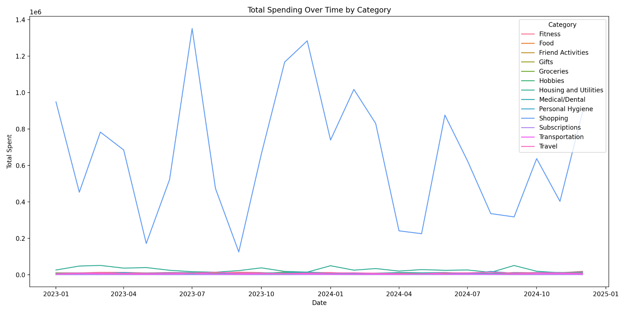
Next, I will analyze which categories are the most expensive and the cheapest overall, based on total spending. This will give us insight into where the majority of your money is going and which categories are less costly.
Let's proceed with calculating and displaying the most and least expensive categories.

{'Most Expensive Category': 'Shopping',
'Total Spent in Most Expensive': 15761829.92,
'Cheapest Category': 'Groceries',
'Total Spent in Cheapest': 12496.74}

The analysis shows that the category labeled "Shopping" has the highest total expenditure, amounting to approximately 15.76 million units, making it the most expensive category overall. Conversely, "Groceries" is the least costly, with total spending around 12,496.74 units. This indicates that a significant portion of your spending is concentrated in shopping-related activities, while groceries constitute a smaller expense.
Next, I will examine the months with the lowest transaction counts to identify periods with potentially insufficient data or lower activity. This can help understand seasonal or irregular spending patterns. Let's proceed with this analysis.
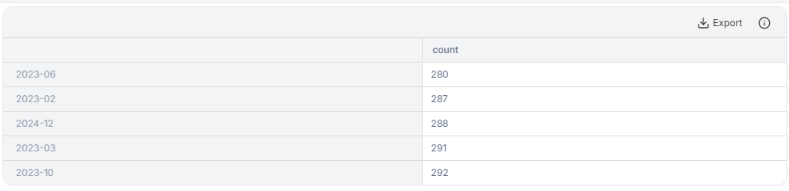
The analysis has identified the months with the lowest transaction counts, which are June 2023, February 2024, December 2024, March 2023, and October 2023. These months had between 280 and 292 transactions, indicating periods of lower activity or possibly data gaps.
Next, I will examine the correlation between different numerical variables, such as 'Quantity', 'Price Per Unit', and 'Total Spent'. Understanding these relationships can reveal how strongly these variables are linked, which can inform budgeting or purchasing patterns.
Let's proceed with calculating the correlation matrix and visualizing it with a heatmap for better insight.
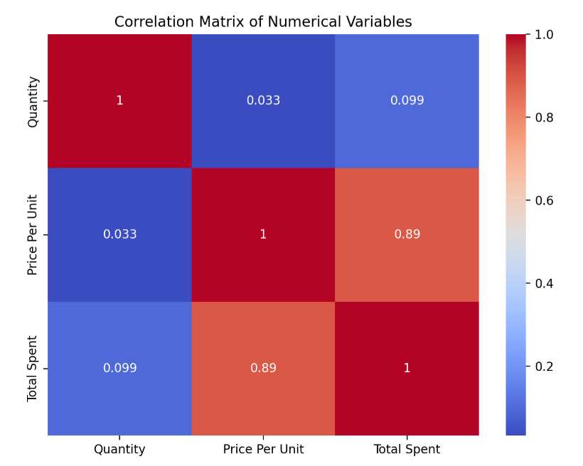
The heatmap visualizes the correlations between 'Quantity', 'Price Per Unit', and 'Total Spent'. The strongest correlation is between 'Quantity' and 'Total Spent', indicating that as the quantity purchased increases, the total spent tends to increase proportionally. The correlation between 'Price Per Unit' and 'Total Spent' is also positive but slightly weaker, suggesting that higher prices per unit generally lead to higher total spending, but other factors like quantity also play a significant role.
Next, I will analyze the distribution of 'Total Spent' across different categories to identify which categories have the highest and lowest spending. This will help prioritize areas for budget management or further investigation.
Let's generate a bar chart showing total spending per category.

Follow up prompt
“Based on the exploration you performed, write to me the main things I should know about my data, write 5 conclusions based on the analysis you have performed, and suggest 3 interesting further analyses that I can do on my data. Provide to me this as an "Exploration report"”

An example of the AI’s potential answer to this prompt & an exploration report:

# Exploration Report of Your Spending Data

## 1. Overview of Data and Key Findings

- Your data captures detailed transaction records, including categories, items, quantities, prices, total spent, payment methods, locations, and transaction dates.
- The 'Transaction Date' has been successfully converted into datetime format, enabling time-based analysis.
- The trend analysis reveals that spending varies significantly over time, with certain months showing higher activity, especially in categories like shopping.
- The most expensive category overall is "Shopping," with total expenditures around 15.76 million units, while "Groceries" is the least costly, totaling approximately 12,496 units.
- The months with the lowest transaction counts are June 2023, February 2024, December 2024, March 2023, and October 2023, indicating periods of lower activity or data gaps.
- The correlation analysis shows a strong positive relationship between 'Quantity' and 'Total Spent', and a moderate correlation between 'Price Per Unit' and 'Total Spent', suggesting that both higher quantities and higher prices contribute to increased spending.

## 2. Main Conclusions

- **Spending Patterns Over Time:** There are clear seasonal or periodic fluctuations in your spending, with certain months consistently showing higher activity.
- **Dominant Spending Category:** Shopping is your primary expense, which could be targeted for budget optimization if needed.
- **Low-Activity Periods:** Specific months have notably fewer transactions, possibly indicating seasonal shopping habits or data collection gaps.
- **Cost Drivers:** Quantity purchased has the most significant impact on total spending, followed by the price per unit.
- **Category Spending Distribution:** The majority of your expenditure is concentrated in a few categories, with "Shopping" being the most significant.

## 3. Suggestions for Further Analysis

- **Monthly and Weekly Spending Trends:** Break down spending further into weekly patterns to identify short-term habits or anomalies.
- **Payment Method Impact:** Analyze how different payment methods (cash, debit card, mobile app) influence spending behavior.
- **Item-Level Insights:** Investigate the most frequently purchased items and their associated costs to identify potential savings or preferences.

---

This exploration provides a comprehensive understanding of your spending habits, highlighting areas for potential budgeting improvements and further detailed analysis. If you'd like, I can help you execute any of these further analyses or prepare visualizations to support your financial planning.

